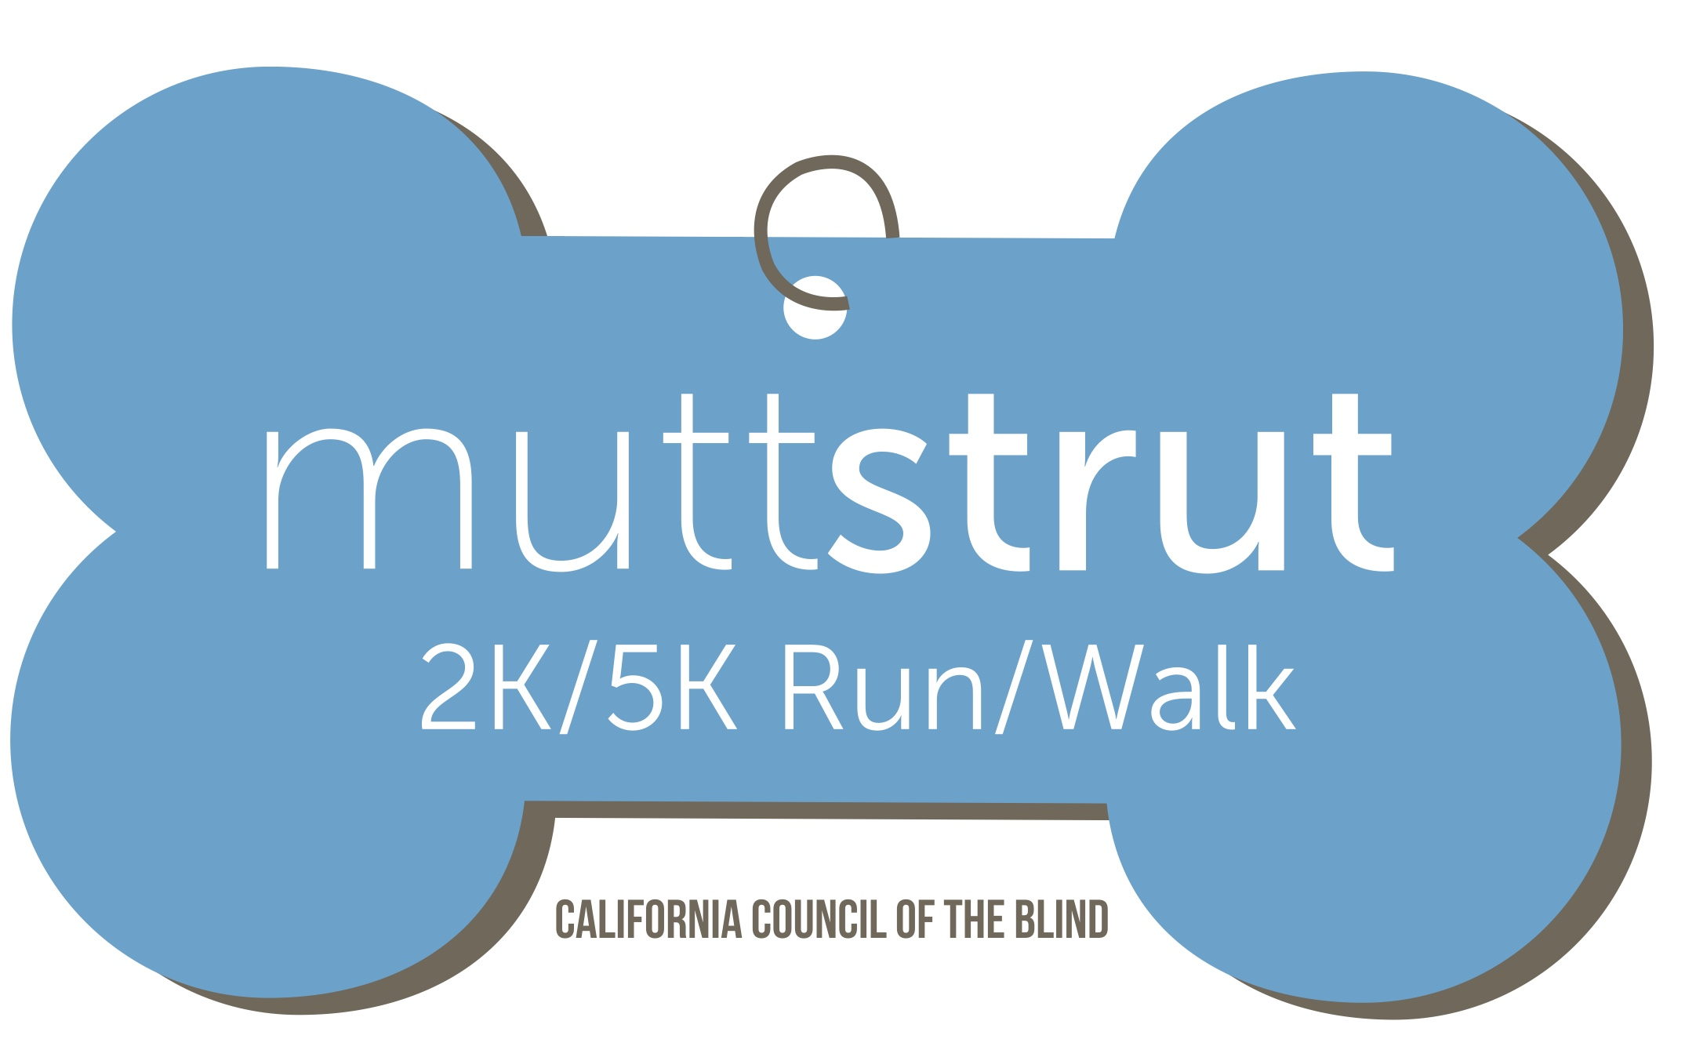
California Council of the Blind
Mutt Strut
Volunteer Information and Interest Form

If you would like to help, please fill out the information below as a Word document and email it to Donna Pomerantz at donna.pomerantz@ccbnet.org or contact her at 626-233-2991 if you have questions about volunteering in the Los Angeles area or Jeff Thom jeff.thom@ccbnet.org or if you have any questions about volunteering call him at 916-995-3967.

Print or type all contact information.

Name: _______________________________
Address:______________________________
City, State and zip:______________________
Email Address:_________________________
Telephone Number (cell):_________________

I am interested in helping prior to the day of the Mutt Strut in performing the tasks below:

Please check all that apply.

☐ Drive a committee member to event-related activities
☐ Store Mutt Strut materials
☐ Distribute Mutt Strut publicity
☐ Obtain items to be donated to the event
☐ Sell raffle tickets
☐ Promote Mutt Strut to my friends and other interested stakeholders
☐ Register participants to the Mutt Strut

Two locations to volunteer.

Please select one:

☐ Los Angeles Area- Saturday, November 14th 2015, I can volunteer to help at the Mutt Strut at Crescenta Valley Park, 3901 Dunsmore Avenue at Honolulu (near the dog park), La Crescenta, CA 91214,

☐ Sacramento Area- Saturday, September 19th 2015 I can volunteer to help at the Mutt Strut at Rusch Park, 7801 Auburn Boulevard at Antelope Road, Citrus Heights, CA 95610

On the day of the event I would like to help with the following activities. Please check all that apply.

☐ Work Registration Table
☐ Work T-shirt Table
☐ Setup / cleanup, e.g. tables/chairs, equipment, etc.
☐ Maintain dog relieving and cooling areas
☐ Work in the food area
☐ Sell raffle tickets
☐ Sighted guide assistance to persons with visual impairments
☐ Work security
☐ Work Water Station
☐ Course monitor/clean up
☐ Race timing assistance (start / finish line)
☐ Area Team Leader
☐ Other, please specify:__________________
_____________________________________

How did you hear about the Mutt Strut? ________________________________________________

